**Probability and Statistics – IT2120**

**Lab Sheet 09**

**IT24610825**

**Bandara A.G.T.S**

1. i)

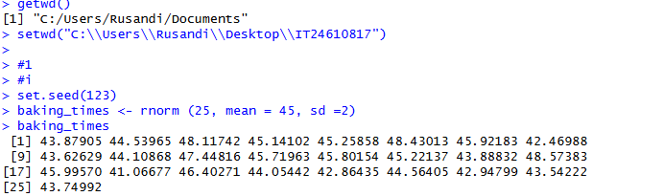

ii)

